1. **Construct the state space diagram for hill climbing search problem. identify the problems in different regions in hill climbing and give reason.**

Hill climbing is a local search algorithm used in artificial intelligence and optimization problems. In this algorithm, the search starts at a randomly selected point and tries to find a local optimum by repeatedly choosing the next-best neighboring state. The algorithm terminates when it reaches a peak or no better neighboring state is found.

The state space diagram for a hill climbing search problem can be constructed as follows:

1. Initial state: This is the starting point of the search algorithm. It is denoted by a circle and labeled as S0.
2. Successor states: From the initial state, the algorithm generates the successor states. These states are represented by squares and labeled as S1, S2, S3, and so on. Each successor state represents a neighboring state that is obtained by making a small change to the current state.
3. Evaluation function: The evaluation function is used to determine the quality of each state. It assigns a numerical value to each state, which represents how close it is to the goal state. The evaluation function is denoted by a diamond.
4. Goal state: The goal state is the state that represents the optimal solution to the problem. It is denoted by a circle with a double border and labeled as SG.

Here is an example state space diagram for a hill climbing search problem:

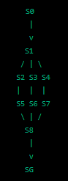

In this diagram, S0 is the initial state, and SG is the goal state. The algorithm generates three successor states from S0: S1, S2, and S3. The evaluation function assigns a value to each of these states based on their proximity to the goal state. In this example, let's assume that S2 has the highest value, followed by S1 and S3.

The algorithm then selects S2 as the current state and generates three more successor states: S5, S6, and S7. Again, the evaluation function assigns a value to each of these states, and let's assume that S6 has the highest value.

The algorithm then selects S6 as the current state and generates one more successor state: S8. However, the evaluation function determines that S8 is not better than S6, so the algorithm terminates and returns S6 as the solution.

Problems in Different Regions of Hill Climbing:

There are several problems that can occur in different regions of the state space diagram for hill climbing:

1. Local maxima: In some regions of the state space diagram, the algorithm can get stuck at a local maximum. This occurs when the algorithm reaches a state that is better than its neighboring states but is not the global optimum. In such cases, the algorithm cannot progress further and terminates prematurely.
2. Plateaus: Plateaus are regions of the state space where there are many states with the same evaluation value. In such regions, the algorithm may get stuck and fail to make progress.
3. Ridges: Ridges are regions of the state space where there are several paths that lead to the same optimal state. In such regions, the algorithm may waste time exploring redundant paths instead of converging quickly to the optimal solution.
4. Steep slopes: Steep slopes are regions of the state space where the difference in evaluation value between neighboring states is large. In such regions, the algorithm may take large steps and overshoot the optimal solution.

To overcome these problems, several variations of the hill climbing algorithm have been proposed, such as simulated annealing, stochastic hill climbing, and local beam search. These algorithms introduce randomization or diversification to the hill climbing search process, which can help the algorithm escape from local maxima, plateaus, ridges, and ravines.

1. **Solve the following crypt arithmetic problem using Constraint satisfaction problem. TWO+TWO = FOUR and write the production rule for solving this problem.**

Constraint satisfaction problem (CSP) is a technique used to solve problems where we need to satisfy a set of constraints. In the given problem, we need to assign unique digits to each letter in such a way that the addition of TWO and TWO equals FOUR. We can solve this problem using CSP as follows:

Step 1: Define the variables and their domains. In this problem, we have three variables: T, W, and F. The domain of each variable is {0, 1, 2, 3, 4, 5, 6, 7, 8, 9}.

Step 2: Define the constraints. The constraints in this problem are:

* Each letter must be assigned a unique digit.
* The addition of TWO and TWO must equal FOUR.

Step 3: Apply constraint propagation. We can apply constraint propagation to reduce the domain of the variables based on the constraints. For example, since the digits in the ones place of TWO and TWO must add up to an even number, we can eliminate all odd numbers from the domain of F.

Step 4: Apply backtracking search. We can apply backtracking search to find a solution to the problem. We start by assigning a value to one of the variables and then recursively assign values to the remaining variables. If at any point, we find that a variable has no available values in its domain, we backtrack and try a different value for the previous variable. We continue this process until we find a solution or exhaust all possible combinations.

Link: <https://www.youtube.com/watch?v=k6gfvYb24jo>

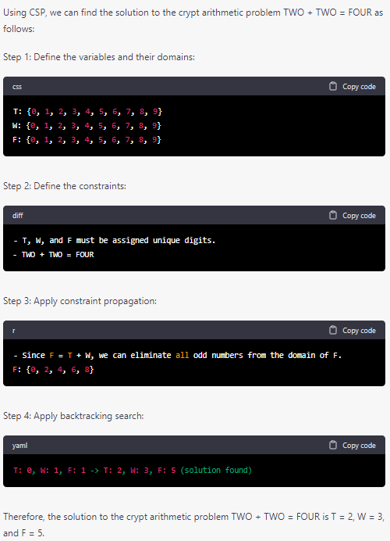

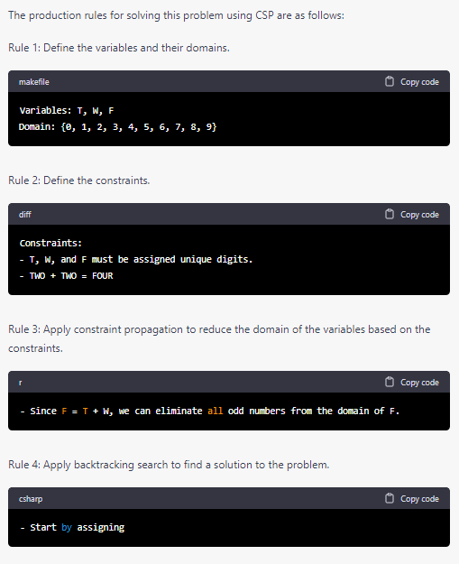

1. **Explain Uncertain Knowledge and reasoning Methods. Bayesian probability and belief network the forward chaining algorithm work for the following problem:**

**Harry installed a new burglar alarm at his home to detect burglary The alarm reliably responds at detecting a burglary but also responds for minor earthquakes. Harry has two neighbors David and Sophia, who have taken a responsibility to inform Harry at work when they hear the alarm David always calls Harry when he hears the alarm, but sometimes he got confused with the phone ringing and calls at that time too. On the other hand, Sophia likes to Listen to high music, so sometimes she misses to hear the alarm. Here we would like to compute the probability of burglary alarm.**

**LINK:** <https://www.javatpoint.com/bayesian-belief-network-in-artificial-intelligence>

1. **Identify the use of predicate logic as a way of representing knowledge by looking at a specific example and prove that Marcus hate Caesar by Consider the following set of sentences for converting in to CNF:**

**1. Marcus was a man.**

**2. Marcus was a Pompeian.**

**3. All Pompeiians were Romans.**

**4. Caesar was a ruler.**

**5. All Pompeiians were either loyal to Caesar or hated him 6. Everyone is loyal to someone.**

**7. People only try to assassinate rulers they are not loyal to 8. Marcus tried to assassinate Caesar.**

**VIDEO 1:** [**https://www.youtube.com/watch?v=OQuKK-rI-x8**](https://www.youtube.com/watch?v=OQuKK-rI-x8)

**VIDEO 2:**

**PART 1:** [**https://youtu.be/tFYngFwDuJQ**](https://youtu.be/tFYngFwDuJQ)

**PART 2:** [**https://www.youtube.com/watch?v=Z0vTGofo2n8**](https://www.youtube.com/watch?v=Z0vTGofo2n8)

1. **Identify the termination condition for the hill climbing algorithm**

The termination condition for the hill climbing algorithm is usually when a local maximum is reached and no better neighbor can be found. In other words, the algorithm terminates when it has reached a point where it cannot improve the current solution any further by changing a single element. At this point, the algorithm assumes that it has found the best solution in the current search space, and it stops the search. However, it is important to note that the hill climbing algorithm may get stuck at a local maximum and fail to find the global maximum. This is known as the local optima problem, which can be addressed by using techniques such as random restart or simulated annealing.

1. **what are the facts are used to represent the propositional and predicate logic with an example**

Propositional logic deals with simple statements that are either true or false. These statements are called propositions or atomic statements, and they are combined using logical operators such as AND, OR, and NOT. Here's an example:

Propositional logic example: Let p be the proposition "It is raining outside." Let q be the proposition "I will stay indoors."

Using propositional logic, we can combine these two statements using logical operators:

p AND q: "It is raining outside and I will stay indoors." p OR q: "It is raining outside or I will stay indoors." NOT p: "It is not raining outside."

Predicate logic, on the other hand, deals with more complex statements that involve variables and quantifiers. These variables are usually denoted by lowercase letters, and quantifiers are used to specify how the variables are related to each other. There are two types of quantifiers in predicate logic: universal quantifier (∀) and existential quantifier (∃).

Predicate logic example: Let P(x) be the predicate "x is a prime number." Let Q(x, y) be the predicate "x is a multiple of y."

Using predicate logic, we can make statements about all or some values of the variable x:

∀xP(x): "All x are prime numbers." ∃xP(x): "There exists an x that is a prime number." ∀x∃yQ(x, y): "For all x, there exists a y such that x is a multiple of y."

These are just a few examples of how propositional and predicate logic can be used to represent statements and facts.

1. **Identify objects ,properties, functions, and relations for the given example "EVIL KING JOHN BROTHER OF RHICARD RULED ENGLAND IN 1200"**

Objects:

* Evil King John
* Richard

Properties:

* Brother (relationship between Evil King John and Richard)
* Ruled (relationship between Evil King John and England)
* Evil (property of King John)

Functions:

* Brother of

Relations:

* Brother (relationship between Evil King John and Richard)
* Ruled (relationship between Evil King John and England)